Importing and exporting images from PACS using MicroDicom

Exporting DICOM files from PACS
- Open the MicroDicom Application on Citrix

- Select Network → Download from DICOM server…
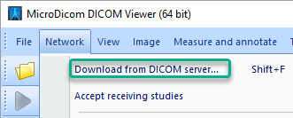
- In the top left of the resulting window ensure that KGH PACS is selected
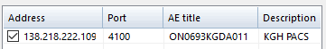
- Select the Patient or Patient ID tab in the upper right, enter the appropriate query details and click “Search”.
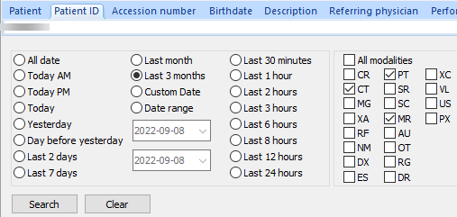
- Identify the appropriate study from the list that appears and click “Download”
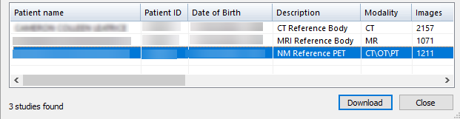
- The typical “downloading window will appear. Note It can take several minutes to download the study.
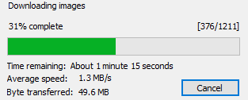
Notes:
- Result Columns can be re-sized and re-ordered, but settings do not appear to be sticky.
- Modality sorting works, but Date sorting does not.
- Results are shown by Study - cannot sub-select a series
- Click row to select (Shift and Ctrl work for multi select)
- Right-click on selection → Download
- Download progress window appears.
- Takes 2-3 min to download a series
- Files are saved without the usual .dcm extension
- Unwanted series can be removed:
  - Right-click on series → Remove → Delete

